**ASSESS THE OVERALL SATISFACTION AND IDENTIFY AREAS OF IMPROVEMENT IN NIBM CAMPUS**

**STATISTICS COURSE WORK**

**HIGHER DIPLOMA IN SOFTWARE ENGINEERING 22.2F NATIONAL INSTITUTE OF BUSINESS MANAGEMENT**

**LHM FERNANDO KAHDSE222F-020**

**NATIONAL INSTITUTE OF BUSINESS MANAGEMENT KANDY REGIONAL CENTER DIPLOMA IN SOFTWARE ENGINEERING**

**CONTENT**

1. Project objective
2. Method of sample selection
3. Expected scope to be covered and scope exclusion
4. Method of data collection
5. Statistical tools to be used in the analysis
6. How to digitalize for a larger population
7. Innovations and key selling points

PROJECT OBJECTIVE

The objective of this project is to assess the overall satisfaction and identify areas of improvement in NIBM campus by gathering feedback from current students, past students, and other individuals associated with the campus. By analyzing the data, i aim to understand perceptions, identify strengths and weaknesses, and make informed recommendations for enhancing the campus experience.

METHOD OF SAMPLE SELECTION

Combination of convenience sampling and snowball sampling methods to select participants. Start by surveying current students and then ask them to refer past students and other individuals connected to the campus.

EXPECTED SCOPE TO BE COVERED AND SCOPE EXCLUSION

The project will focus on gathering feedback related to the campus experience, including academics, facilities, extracurricular activities, support services, and overall satisfaction. Scope exclusion may include factors unrelated to the campus environment, such as personal circumstances or external factors.

METHOD OF DATA COLLECTION

* Utilize a combination of survey/questionnaire and interviews to collect data.
* Design a comprehensive survey/questionnaire that covers various aspects of the campus experience and encourages participants to provide detailed feedback.
* Conduct interviews with a subset of participants to gather more in-depth insights and perspectives.

[https://docs.google.com/forms/d/17qj2TmKgbHVEZxBfWQCzBqF pDzdBP8pGESMk8-BOcNs/edit?chromeless=1](https://docs.google.com/forms/d/17qj2TmKgbHVEZxBfWQCzBqF%20pDzdBP8pGESMk8-BOcNs/edit?chromeless=1)

[https://docs.google.com/spreadsheets/d/1V1qTHmjskuzp2kpO4ihmBdaB4nGd9zf/edit?usp=drivesdk&ouid=109612488 775937028682&rtpof=true&sd=true](https://docs.google.com/spreadsheets/d/1V1qTHmjs%20kuzp2kpO4ihmBdaB4nGd9zf/edit?usp=drivesdk&ouid=109612488%20775937028682&rtpof=true&sd=true)

STATISTICAL TOOLS TO BE USED IN THE ANALYSIS

• Descriptive statistics

• Correlation

• regression

• Probability

• Permutations + Probability

• Normal distribution

To representthe data

• Google forms

• Power BI

GPA VS STUDENT’S SATISFACTION

• Correlation • Regression

[https://drive.google.com/file/d/1V8BJTDkFfGWrV2pmpdxF1TvvUL R7SSOO/view?usp=drivesdk](https://drive.google.com/file/d/1V8BJTDkFfGWrV2pmpdxF1TvvUL%20R7SSOO/view?usp=drivesdk)

could not find any patterns

could not apply for others in case of could not find any correlation & regression patterns

NORMAL DISTRIBUTION

fit

Did not fit

PROBABILITY

Probability of a student is a boy p(boy) = 0.654

Probability of a student is a girl p(girl) = 0.320

Permutations +Probability

P(boy who did not do a job) = 0.21

P(girl who do a job) = 0.48

P(boy who do a job) =0.89

P(girl who did not do a job) = 0.52

Probability of a student is a boy and do a job

P(boy)*p(boy who do a job) = 0.654*0.89=0.582

DESCRIPTIVE STATISTICS.

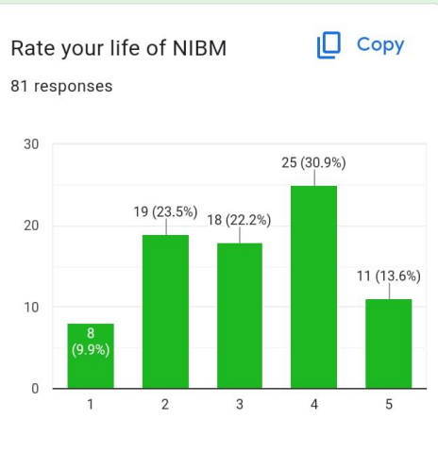

mean satisfaction x bar=3.12

average level

INNOVATIONS

LOW SATISFACTION FOR EXTRACURRICULAR ACTIVITIES

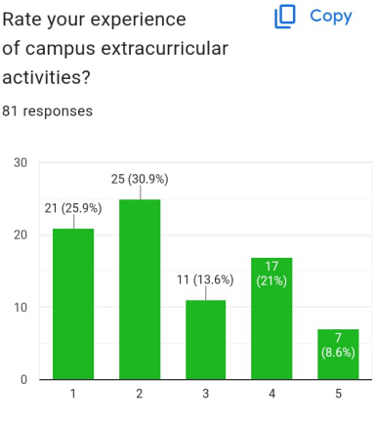

Not fit with normal distribution student have low satisfaction with extracurricular activities

LOW AMOUNT OF FEMALES

[https://drive.google.com/file/d/1VCspxYlABGd2 b7G0r1_9LViXgL-AqBU4/view?usp=drivesdk](https://drive.google.com/file/d/1VCspxYlABGd2%20b7G0r1_9LViXgL-AqBU4/view?usp=drivesdk)

BRANCH WISE

[https://drive.google.com/file/d/1VIigx6t4PmKOTtJX43dYP4d8py8P Urso/view?usp=drivesdk](https://drive.google.com/file/d/1VIigx6t4PmKOTtJX43dYP4d8py8P%20Urso/view?usp=drivesdk)

INNOVATIONS AND KEY SELLING POINTS

* Longitudinal analysis: If possible, I hope to consider conducting longitudinal analysis by periodically collecting data over a specific timeframe to track changes in satisfaction levels or identify trends in perceptions.
* Heatmap visualization: I hope to use heatmap visualization techniques to present the overall satisfaction levels across different aspects of the campus, providing a visually appealing and informative summary of the findings.
* Stakeholder engagement: I hope to engage key stakeholders, such as campus administrators or student organizations, in the analysis and decision-making process to ensure the findings are considered and implemented effectively.

HOW TO DIGITALIZE FOR A LARGER POPULATION

* To reach a larger population and digitalize data collection, I hope to develop an online survey using platforms like Google Forms or SurveyMonkey. share the survey link through various channels, such as email, social media groups, or campus websites, to reach current students, past students, and other relevant individuals
* Used classes to collect the data & do calculations